Standard Operating Procedures for Inputting Event Registration
- When someone walks in the Scout Shop and registers for a council event with a registration form, check to see if they are either
  - Making a new registration
  - Paying for an online registration
If they are paying for an online registration skip to step 11
- Take the hard copy form from the customer
- Ring up in SellWise in specified event
- When the transaction is complete attach the receipt to the registration form
- ASAP but definitely before closing the Scout Shop, input all information into the online registration form
Steps to input:
- Log on to the council website
  - www.mississippivalleybsa.org
- Click on “More info” on the calendar and events section
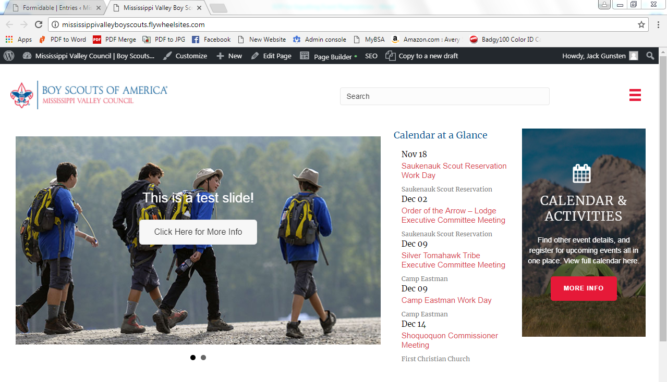

- Find the specific event on the calendar and click it, taking you into the event
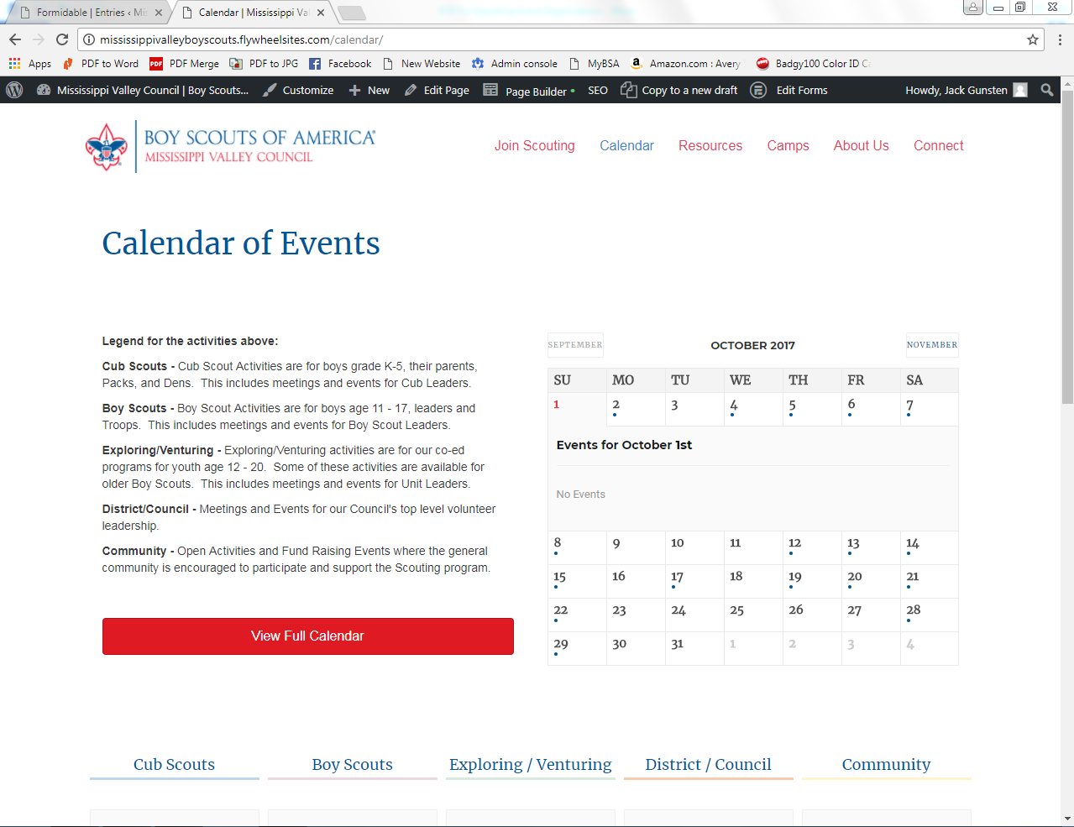

- Scroll down on the event where the form is and input all the necessary information into the digital form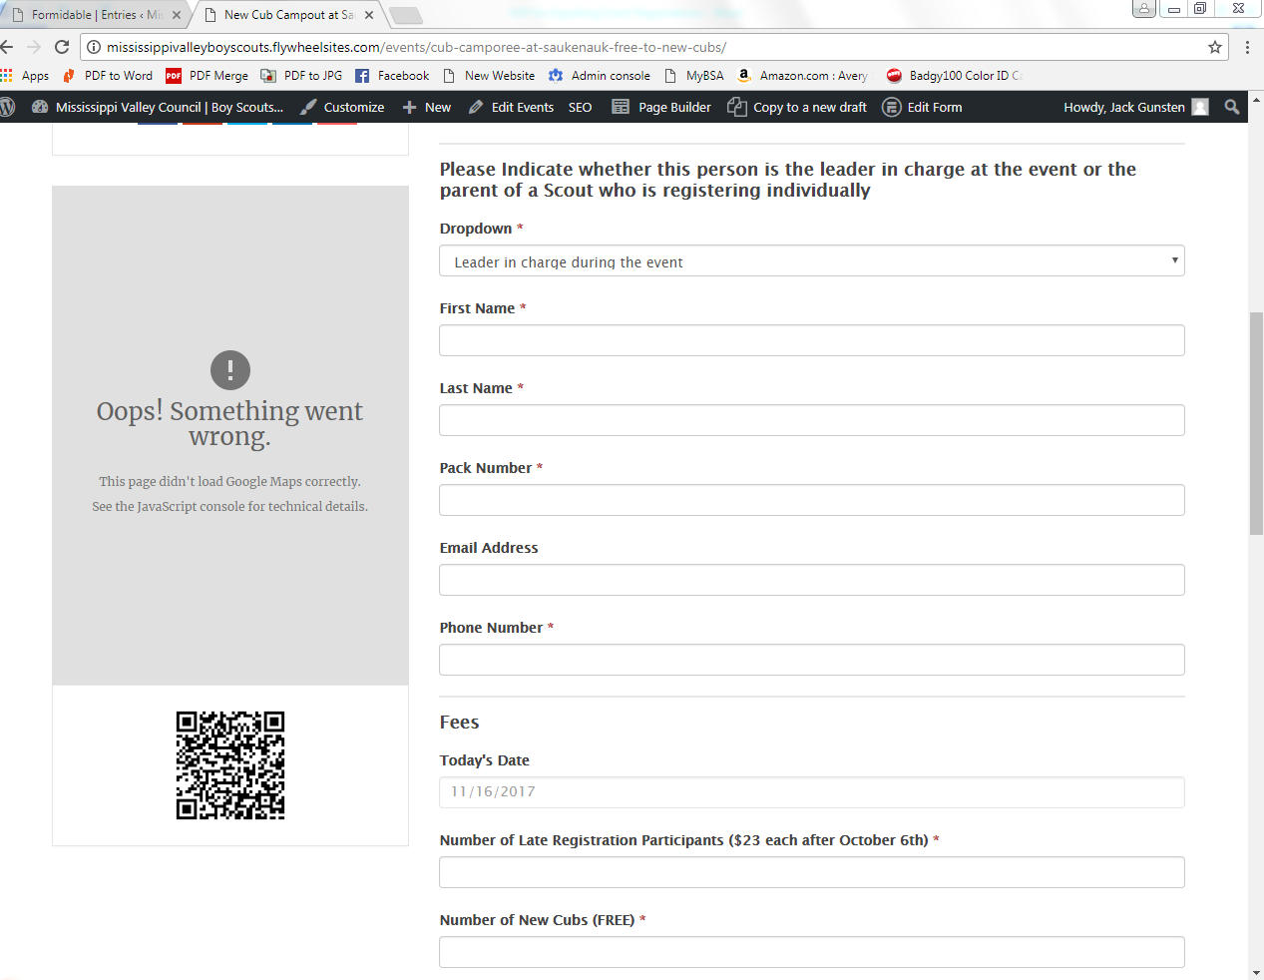
- When a customer pays for an event in the Scout Shop select the “Paid in Scout Shop” button. Also input the receipt number and any notes, example: special requests. Hit submit! You are done.
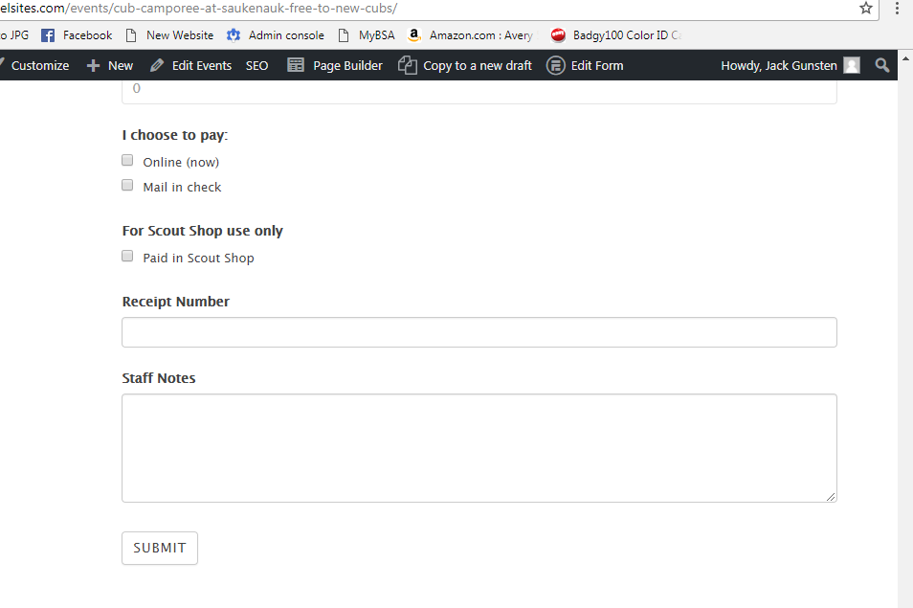

Steps to edit entries (When someone registers online, how to update the online entry)
- Ring up payment in SellWise under the specified event
- Attach the receipt to the registration form. Customer is done with the process.
- As soon as possible put the registration form in the appropriate staff member’s mailbox
- Log onto the council website
  - www.mississippivalleybsa.org
- On the left hand side of the page click Forms
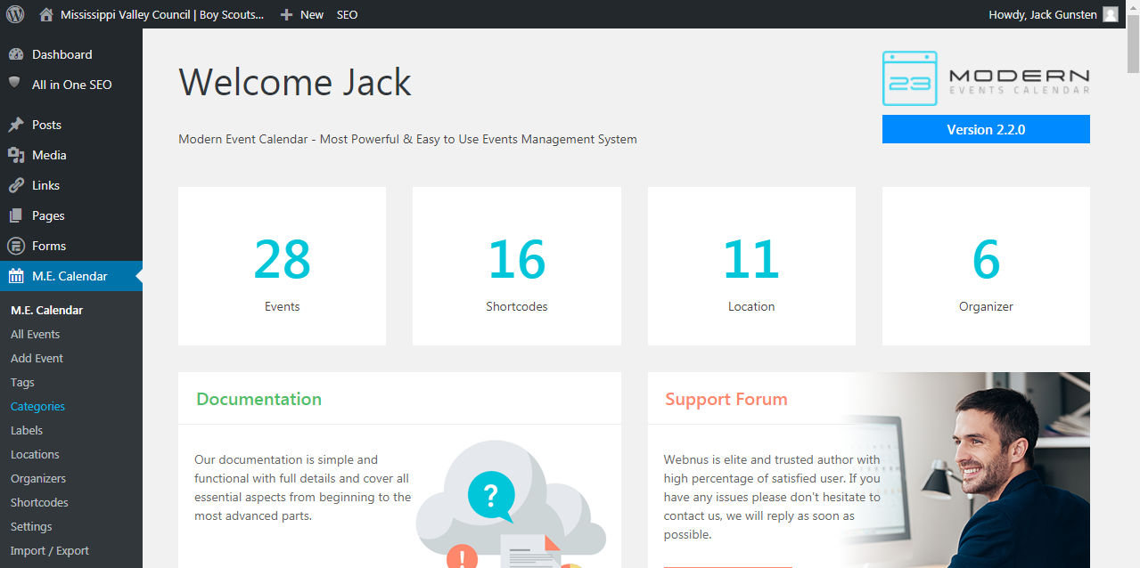

- When you click forms, options will appear and click “Entries”
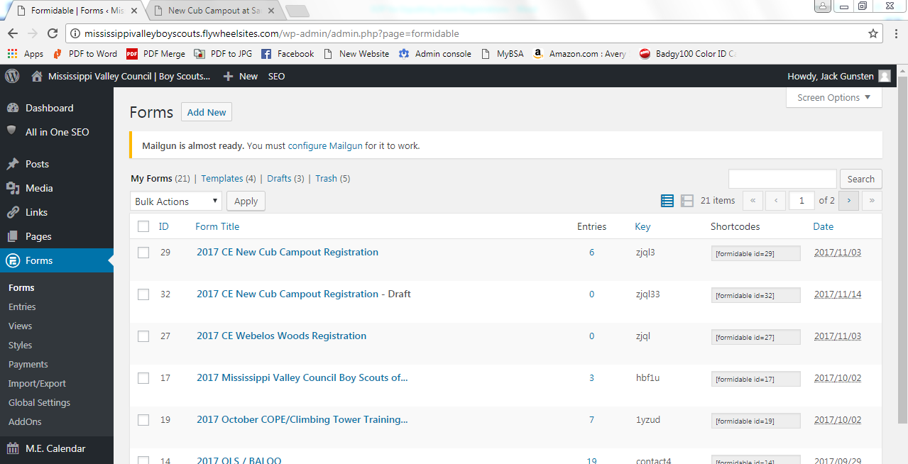

- Click “View all forms” dropdown box and select your event, then click filter
- Scroll until you find the name of the person you are updating the form for
- Hover over the person’s entry and click “Edit”
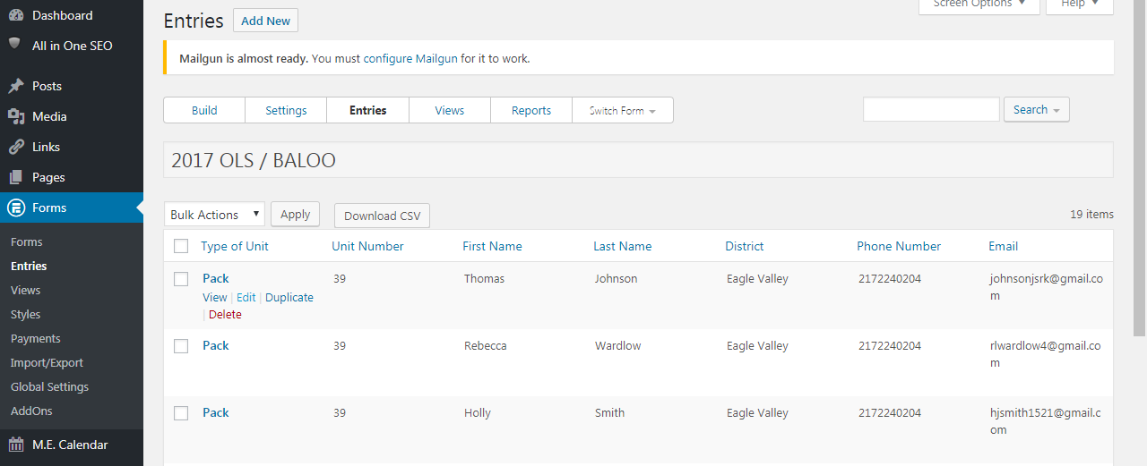

- Once you’ve clicked edit, scroll down on the form and complete the following:
  - Click “Paid in Scout Shops”
  - Enter the receipt number
  - Add any additional notes in the Staff notes section
- When done, hit “Update”
You are done!
