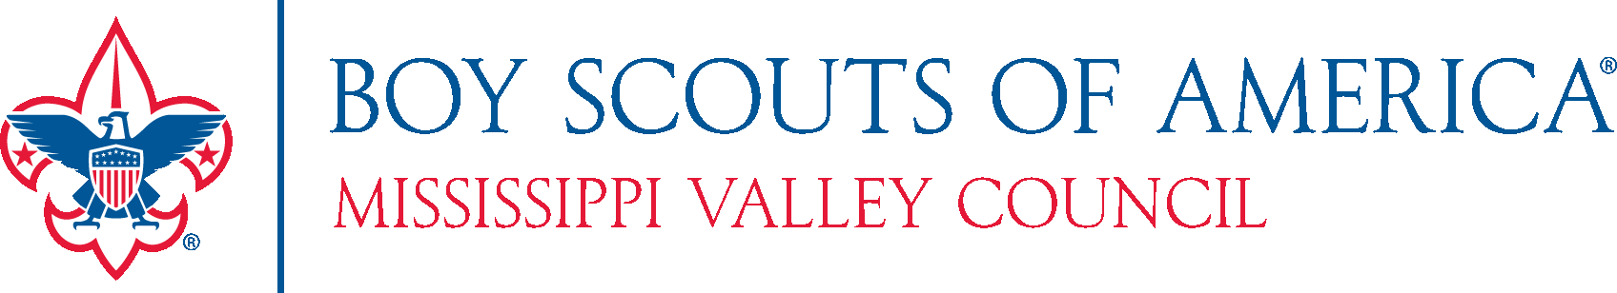

Permission to Seek Funding from United Ways,
Foundations, Trusts, and other Grantors

Foundations, Trusts, and other Grantors
The Mississippi Valley Council intends to seek financial support from several organizations during the fiscal year. Funding may be for the current year or for funds to be realized in future years. The Scout Executive is authorized to enter into agreements with grantors. This includes, but is not limited to, public grants, private grants and United Way funding.

The Mississippi Valley Council also intends to be a partner agency with the United Ways which support our Service Area. We approve the Scout Executive to enter into agreements with these United Ways for 2020 and 2021.

Adopted February 7, 2015
Ratified February 9, 2019
Executive Committee Reviewed January 21, 2020

