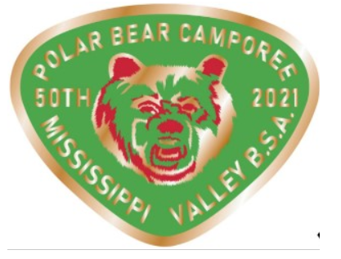
Virtual Polar Bear 2021
Agenda

9am – Opening and Welcome
9:15am – Knot Challenge
10:15 am – Scout Trivia – Kahoot Live Event
11:00 am – Campfire Competition
12:00 pm – Foil Packet Video Demonstration
1:00 pm – Winter Camping Course
2:00 pm – Snow and/or Ice Sculpture
3:00 pm – Backyard pioneering Project
4:00 pm – Closing

