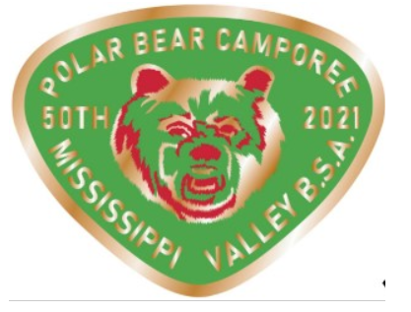
Virtual Polar Bear 2021
Supply List

Will need a phone, tablet or computer to upload pictures/videos to FaceBook Group

- Knot Challenge
  - Rope: Two - 6' pieces per person and small piece of wood or stick
- Polar Plunge
  - Bucket of Ice Water
- Scout BSA Brain Teasers
  - Kahoot App
- Campfire Challenge
  - Safe Area to build Fire and Fire Building Supplies
- Foil Packet Meal
  - Aluminum Foil, butter, 4oz protein, 1/2 cup assorted canned veggies, starch's, and seasonings per person
- Indoor Snow Sculptures
  - Toothpicks and Marshmallows
- Pioneering Projects
  - Sticks, tarp and Rope

