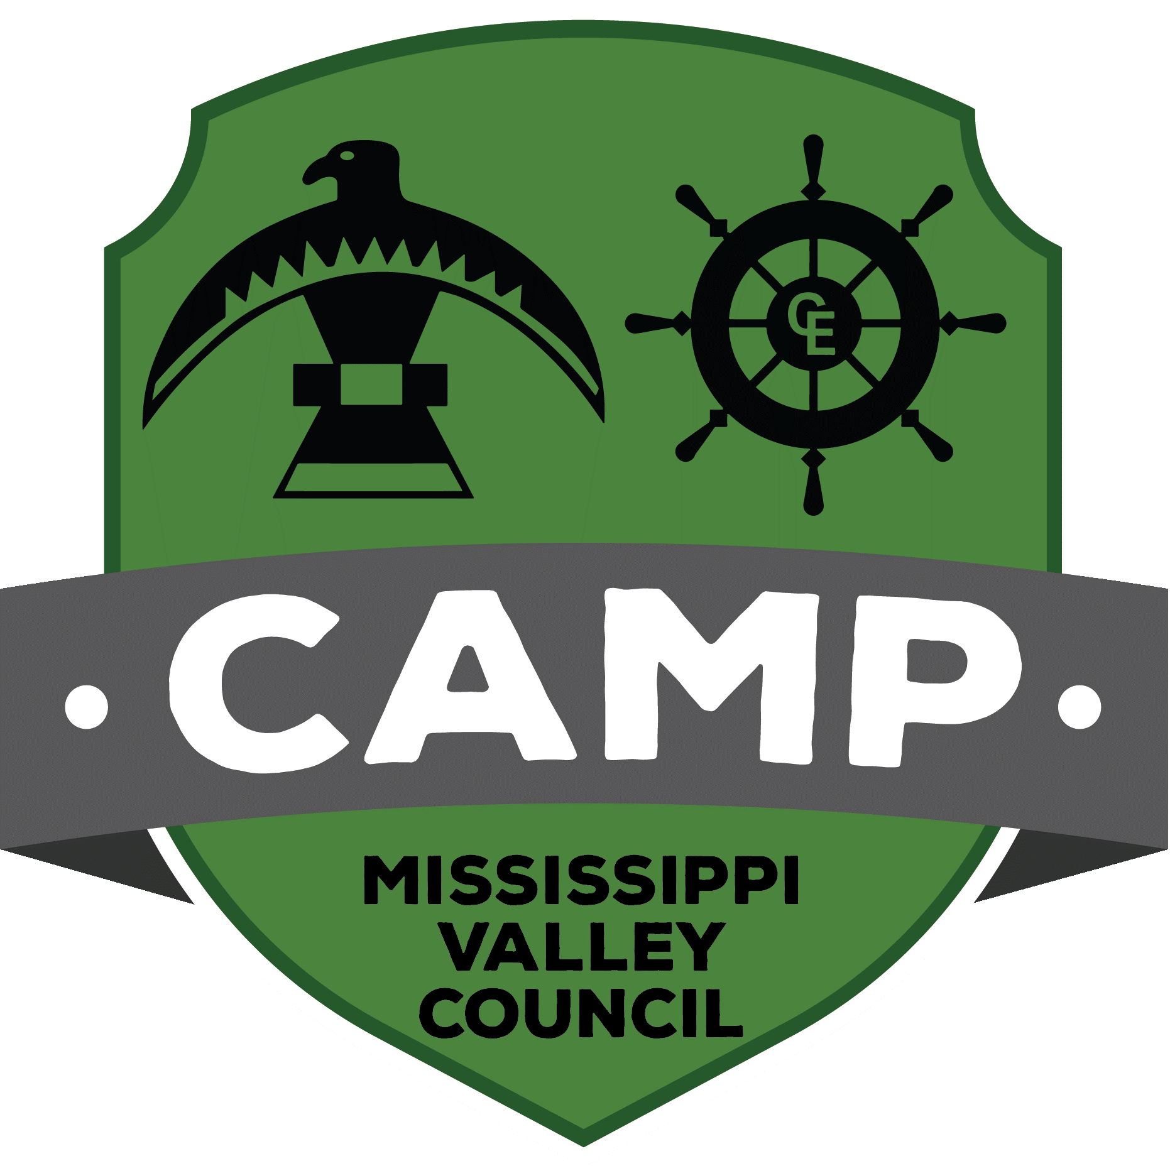
Merit Badge Name
Program Area
Mississippi Valley Council - 2021 Summer Camp

Day of Week:
Duration: 50 Minutes
Counselor:
Date Written/Updated:

Resources
- Merit Badge Pamphlet

Materials Needed

Learning Objectives/Requirements Covered (2 Minute)
- Requirement Covered & one sentence about what you want them to learn.

Discovery (5 Minutes)
Ask the group 3-5 questions to see how much they know about what you’re about to teach

Skill Instruction (36 Minutes)

Learn Skill (5 Min)
Teach them what you want them to know. May take fewer than 5 minutes or longer. You may have 2, 3, or 4 things to cover in each of your four days of teaching depending on the scope of the requirement.

Game/Activity (13 Min)
Do a game, activity, challenge, adventure that helps reinforce the lesson you want them to learn. This is the most important & fun part of the merit badge.

Learn Skill (5 Min)
Teach them what you want them to know. May take fewer than 5 minutes or longer. You may have 2, 3, or 4 things to cover in each of your four days of teaching depending on the scope of the requirement.

Game/Activity (13 Min)
Do a game, activity, challenge, adventure that helps reinforce the lesson you want them to learn. This is the most important & fun part of the merit badge.

Evaluation (5 Minutes)
Ask them what they’ve learned in your class today. Try to get a sense that they understood the lessons you were trying to teach and how the activities applied to the requirements and the merit badge topic.

Summary (2 Minute)
Review Learning Objectives and confirm with the Scouts that you covered them all.

