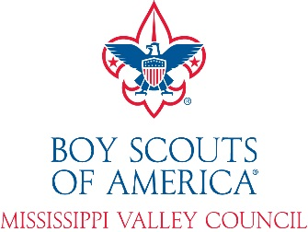
Summer Camp Refund Request Form
Council Refund Policy:
In all programs offered by the Mississippi Valley Council, BSA, a great deal of planning and purchasing takes place well in advance. These plans include, but are not limited to, staff, food, program materials, patches and awards, rental and purchase of equipment, and in some cases, items of clothing such as T-shirts that are given as part of a program fee. When an individual or group makes a reservation for an activity or program, these items are included in ordering of materials and staffing for that event.
Summer Camp Refunds:
Individuals that cancel their reservation by June 1, 2021 will receive a refund of fees paid, less an administrative charge. Administrative Charges are based upon the date the refund request was received. Requests received by May 1st will have a 15% administrative charge. Requests received after May 1st will have a 25% administrative charge. No refunds will be made after June 1, 2021 unless there is a medical or other emergency that prohibited a participant from attending.
If there was a medical or other emergency after June 1st, a refund request form should be sent to Mississippi Valley Council. The request is due to the service center before August 1, 2021. Please be specific and include additional documents if needed (doctor’s note, etc.) Refunds will not be granted for schedule conflicts (vacations, sports, etc.), dropping out, no-shows, weather conditions, or behavior issues.
All refunds are first considered by the volunteer committee chairman and professional staff advisor providing leadership to the event. Decisions may be appealed to the Treasurer of the Council. Refunds received after June 1st will be considered at the conclusion of Summer Camp.
Participant Name: __________________________________ Unit Number: _____________
Address: ______________________________ City: _______________ State: _____ Zip: _________
Phone Number: ______________________________ E-mail: __________________________________
Refund requested for: (Circle)
Cub Scout Camp Webelos Camp Scouts BSA NYLT
Total Amount Paid: $____________
Specific reason(s) for refund request: (attach additional sheet if needed)
_____________________________________________________________________________________
_____________________________________________________________________________________
Parent/Guardian Signature: __________________________________________ Date: ______________
Unit Leader Signature: ______________________________________________ Date: ______________

