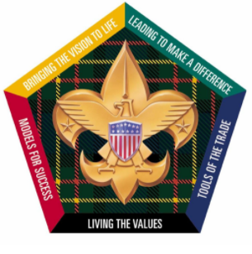
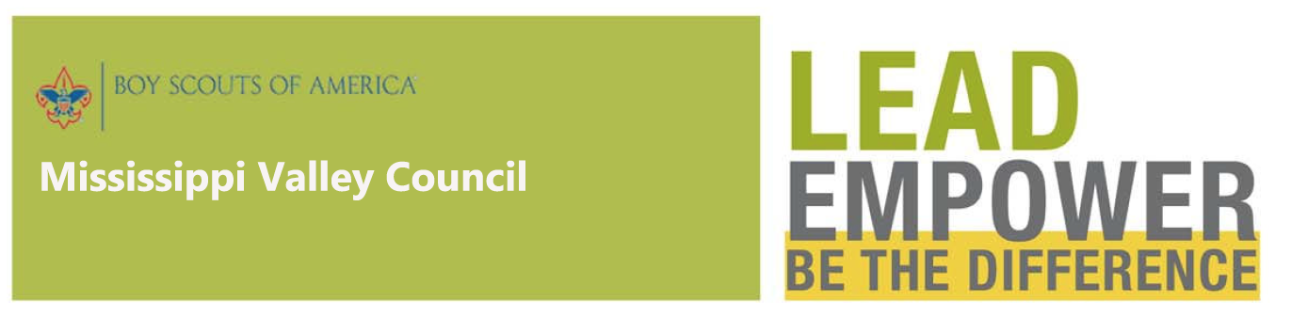
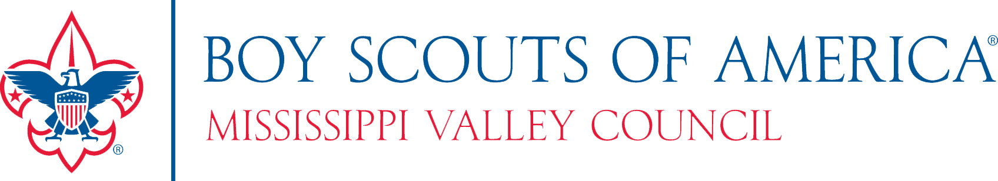
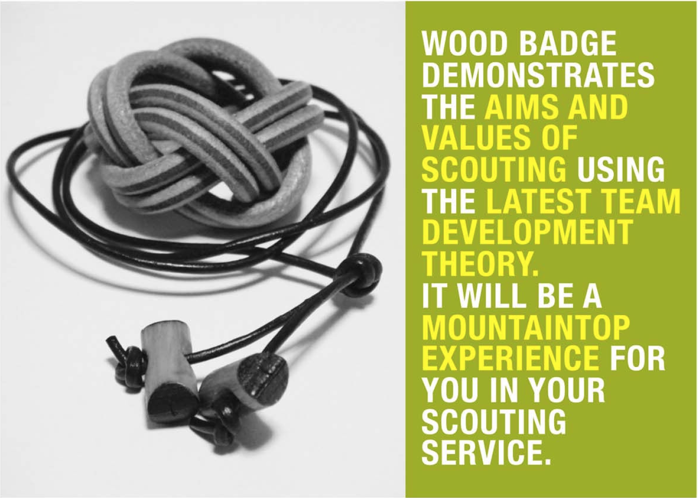
TWO THREE-DAY SESSIONS (REQUIRED)
SEPTEMBER 23-25 2022 &
OCTOBER 7-9 2022

Learn contemporary leadership concepts and discover how to apply them as part of a successful working team and in your Scouting service.

FOR MORE INFORMATION
Contact the Course Director or Staff Advisor
Mark Crooks Heather Huebner
majcrooks@msn.com heather.huebner@scouting.org

WOOD BADGE IS THE ADVANCED TRAINING COURSE FOR ADULT SCOUT LEADERS:
CUB SCOUT, BOY SCOUT, VENTURING, DISTRICT AND COUNCIL VOLUNTEERS AND PROFESSIONAL SCOUT LEADERS.

The program consists of two parts:

- PRACTICAL TRAINING
During the six-day outdoor event, you will live the patrol method. As a member of a patrol, you will practice skills of leadership and learn how to apply these skills in your role as an adult Scouting leader. Your Scouting spirit and enthusiasm will be renewed and you’ll find yourself doing a better job in your Scouting roles.

This portion of the course is presented over two three-day sessions. A mandatory meeting of your patrol will be held between the two sessions.

- APPLYING WHAT YOU LEARN
During practical training you will write your ticket-a set of goals designed by you to be accomplished by you. You will work your ticket, utilizing aspects of what you learned. A ticket counselor will work with you to provide help and encouragement.

Accomplishing the goals may provide service to others, strengthen your unit Scouting program or assist you in an area of personal growth.

The application phase begins at the end of practical training and lasts 18 months, during which you must complete your ticket.

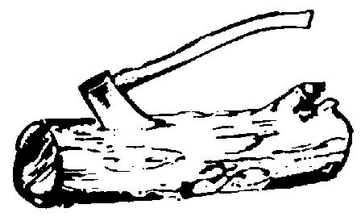

.

LIVING ARRANGEMENTS AND EQUIPMENT
You will sleep in your personal tent in a jamboree setting during the first session and move to a patrol outdoor setting for the second session. Meals for the course are during the first session served in the dining hall. For the outdoor weekend each patrol cooks for itself from its own menu.

UNIFORM
You’ll wear BSA Field and Activity uniforms appropriate for your primary role in Scouting.

PHYSICAL REQUIREMENTS
There is a fair amount of physical activity in a Wood Badge course. However, most limitations can be accommodated. Contact the course director with any questions before submitting your application. Submit a current BSA Medical Form (Parts A, B, & C completed).

RECOGNITION
When you successfully complete your ticket, you’ll be entitled to receive Wood Badge recognition, which consists of “beads” (two wooden beads on a leather thong), a tan neckerchief, leather woggle and a certificate. These will identify you as a Scouter who has completed this advanced training; they also serve to remind you of your ongoing commitment to Scouting.

COST AND SCHOLARSHIPS
The course fee is $200 which includes materials, facilities and meals. If paid in full before July 1, the fee is discounted to $180. Scholarships may be available. Your employer may also be willing to cover costs of this leadership training program.

REGISTER ONLINE
Online registration is the preferred method to join the course. A $60 deposit is required with registration, with the balance due by July 1, 2022.

QUALIFICATIONS
You must be a registered adult leader and have completed Youth Protection and Basic Leader Specific Training, including outdoor portions appropriate to your position in Scouting. All training must be completed prior to the start of the course. Due to the advanced nature of the training, these requirements may not be waived

COURSE SIZE IS LIMITED!

