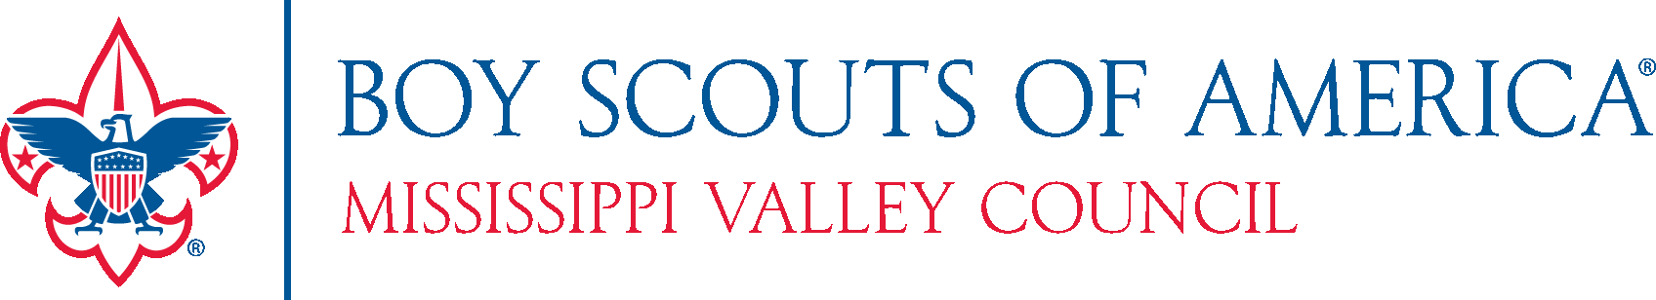



***You are Cordially Invited to   
The 2022 Annual Council Dinner***

*Saturday, February 19, 2022*

*PZAZZ! Convention & Event Center*

*3001 Winegard Dr., Burlington, IA 52601*



2022

We will celebrate and recognize outstanding Scouters and the accomplishments that made our Council successful in 2021 and look forward to future progress in our Scouting World. This year’s theme is “Mask”uerade. Please wear your favorite Mardi Gras style attire. Best Mardi Gras mask wins a prize!

**EVENING HIGHLIGHTS**Silver Beaver Recognition – The highest award bestowed on a volunteer by the Scout Council  
Spirit of Scouting Award – Recognizing outstanding community members and organizations  
Top Popcorn Salespeople  
Unit Recognition for Service Hours and Journey to Excellence

**EVENING SCHEDULE**  
Social Hour – 5:30 PM – 6:30 PM

Buffet Dinner – 6:30 PM

**OVERNIGHT ACCOMMODATIONS**Room Reservations can be made by calling 319-753-2946 and ask for the **BOY SCOUTS Room Block**  
Room Rates: $179/night or $149.00/night and must be reserved before 2/10/22 – *Limited Availability!*

---------------------------------------------------------------------------------------------------------------------------------------

**COUNCIL ANNUAL DINNER REGISTRATION**

Make checks payable to: ***Boy Scouts of America***

***Register by January 21st and save $5.00 on your registration fee!***

____ Yes, I can attend! Reserve ____ seats at $40.00 per person ($35.00 if paid before 2/2/22).

____ Reserve a full table of 8 for $300.00 ($260.00 if paid before 2/2/22) – Please list names below

____ I cannot attend but have enclosed a donation to support the event.

Total Amount Enclosed: $_________________

Name(s) ______________________________________________________________________

E-Mail: _______________________________________________________________________

Sign up online (<https://www.mississippivalleybsa.org/events/2022-council-annual-dinner-2/>), Or mail to:

Mississippi Valley Council Mississippi Valley Council

2522 Locust Street ***OR*** 3007 Flint Hills Drive

Quincy, IL 62301 Burlington, IA 52601

If you have any questions, contact Donna Buss at [busses1640@gmail.com](mailto:busses1640@gmail.com) or 309-313-2561

