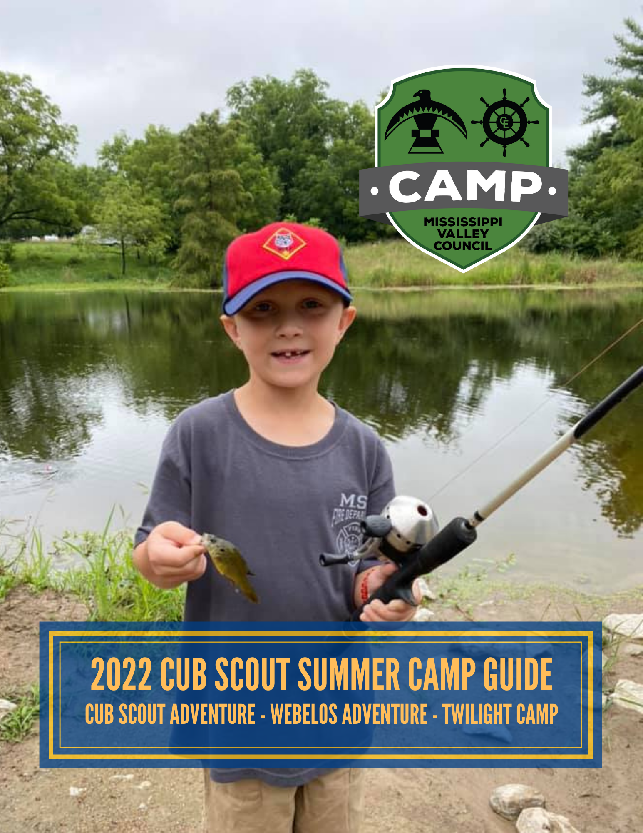
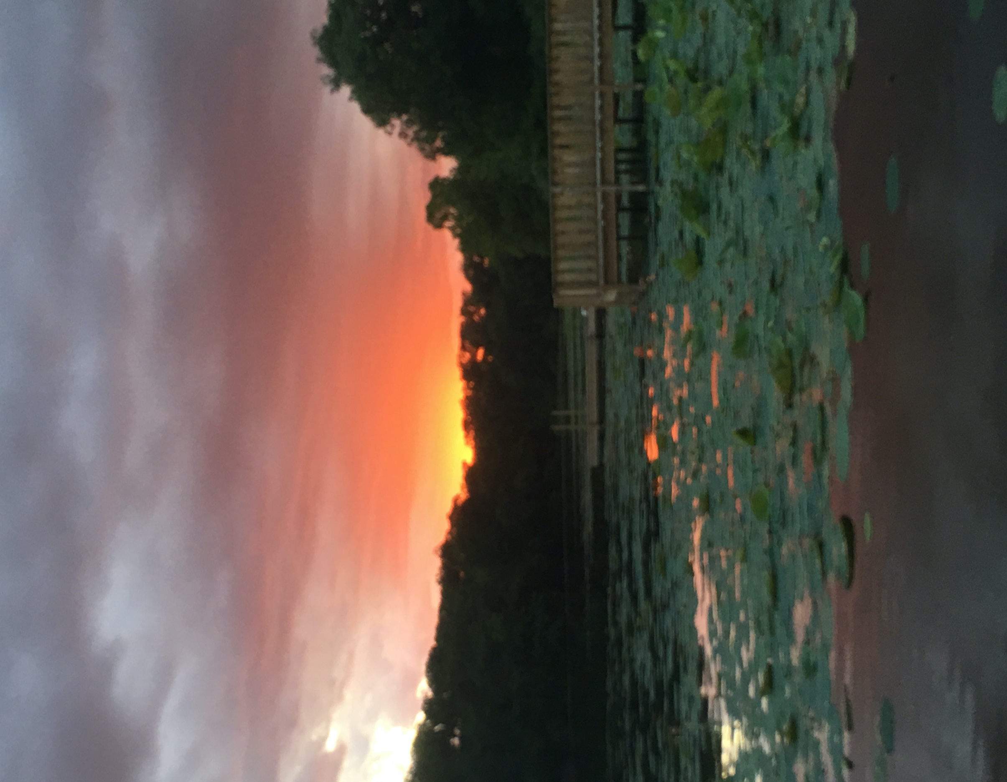

Close your eyes and think back to when you were a kid. You probably attended a camp, whether it was Scout Camp, Church Camp, or some other outdoor program. What do you remember? Probably the friends you made, the challenges you overcame, and adventures that unfolded. Our Camp Staff is committed to ensuring your Scout develops memories that last a lifetime.

Webelos Adventure Camp
Webelos Adventure Camp is hosted at Saukenauk Scout Reservation, 602 acres of prime Scout realty that features a lake perfect for swimming and boating, swimming beach, climbing tower, ziplines, trails for biking and hiking, and so much more!

Cub Scout Adventure Camp
Cub Scout Adventure Camp will be held at Camp Eastman. Situated on the Might Mississippi Camp Eastman provides on ideal setting for boys and girls of all ages. There are creek beds to explore and trails to hike.

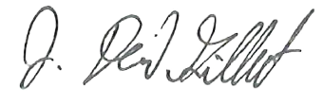
J. David Gilbert Kim Thompson Cordaro Boughton
Camp Director Program Director Camp Director

Table of Contents
Table of Contents 3
Cub Scout Adventure Camp 4
Webelos Adventure Camp 4
Organizing Your Unit 12
Camp Rules 14
Health and Safety 16

Forms & Documents
Visit our website at https://www.mississippivalleybsa.org/camps/camp-resources-3/ for more resources including:
• 2022 Camp Staff Application
• BSA Annual Health and Medical Record
(Linked to National Website)
• Mississippi Valley Council Campership Form
• Refund Request Form
• Swim Test Certification
• Scout Release Request
• Camp Maps

Cub Scout Adventure Camp

A 2-Night/3-Day adventure at Camp Eastman, located off the Mississippi River. Scouts have the opportunity to experience life-changing adventures as they learn new skills, make new friends, and experience nature like never before! This camp is designed for the family to have a great time in the outdoors, we encourage every Scout to have a parent attend to assist with activities and join in on the fun!

WHO: Boys & girls entering grades 1-3 in the fall, their parents, leaders, and den chiefs

WHEN: Three opportunities from which to choose:
Session A June 10 - 12
Session B June 16 - 18 – Thursday – Saturday to avoid Father’s Day
Session C June 24 - 26

COST: Below is the price structure. Camperships, fundraising opportunities, and camper savings opportunities are available.

 | Cub Scout
2022 Early Bird  If deposit is paid by 4/16/22 | $140/Scout  $75/Adult
2022 Standard Price  If fees paid after 4/16/22 | $165/Scout  $100/Adult

Adventure Awaits
Archery – Learn to shoot with bows and arrows. Our amazing staff will help you succeed whether it’s your first time shooting or you’re trying to hone your skills. Travel back in time to the time of knights and kingdoms, where Robin Hood once roamed.

Aquatics – The Wolf aquatic elective is called Spirit of the Water. What an awesome description of how it feels when you jump in a pool on a hot day. No matter how worn out or tired you feel from the heat, once you’re in the pool, that Spirit brings back energy and excitement. Let the fun begin and let the spirit flow!

RC Race Cars – Enter the future and race against your friends with Traxxas Race Cars! Zoom around a track and navigate bumps in this fast-paced grand prix!

BB Guns – This is one of the favorite areas for new Scouts to camp. Your Scout will learn proper safety rules for handling a firearm and put those new skills into practice as you aim at various targets. Learn about the Wild West, and the importance of being prepared!

C.O.P.E –Scouts will work through an obstacle course as they learn basic Challenging Outdoor Personal Experience (C.O.P.E.) skills. Some obstacles they can navigate on their own and others they will need to work as a team.

Scout Craft – It’s important to build lasting memories and experiences! Join us for a fun activity documenting your time at camp this summer and giving back, too!

Hike — Few scouts have experienced the wonders that the woods have to offer. The sights and sounds at Camp Eastman are breath taking. Learn how to use a compass and orient yourself when you are traveling.

S.T.E.M./ Nature – Scouts will be gaining experience with working with wood and basic hand tools. They will be testing theories and making decisions about the engineering process. Likewise, they will learn about an important species in our ecosystem.

Waterfront – Enjoy making memories fishing or canoeing on the pond while learning about how canoes offered transportation for generations of people coming down the Mississippi River and other waterways.

Family Night & Visiting Camp

Family Night Schedule

4:00PM – Families start arriving at Camp
5:45PM – Flag Ceremony
6:00PM – Dinner at and around Dining Hall
7:30PM – Gather for Campfire at Dining Hall
Visitors and family are welcome to join us for dinner. Meal tickets are $7.00 per person and can be purchased at the Trading Post. A headcount of visitors should be submitted during check-in.

Tentative Daily Schedule - Cub Scout Adventure Camp

 | Day 1 | Day 2 | Day 3
7:00 AM
7:15 AM |  |  | Scout is Reverent (Optional)
7:45 AM |  | Flags | Flags
8:00 AM |  | Breakfast | Breakfast
8:45 AM
9:00 AM |  | Morning Activity Schedule | Program #1
9:45 AM |  |  | Transfer Time
10:00 AM | Early Bird Arrival  *May drive to campsite to unload  *Setup campsite  *Various program areas open. |  | Program #2
10:45 AM |  |  | Transfer Time
11:00 AM |  |  | Program #3
11:30 AM | Camp-In Registration  *No vehicles allowed in camp*  1. Medical check-in  2. Swim Check 3. Set up Camp Site  *If arriving after 3:00 pm, please  go to Trading Post.  Camp Wide Activities, after check-in process is completed.
11:45 AM |  |  | Sack Lunches Available in Trading Post
12:00 PM |  | Lunch
12:15 PM |  |  | Check Out  *May Drive into campsite to load
12:30 PM
12:45 PM |  | Transfer Time
1:00 PM |  | Afternoon Activity Schedule
1:45 PM |  |  | Check-Out by 1:00PM BEFORE LEAVING  1. Clean latrines  2. Patrol campsites for litter and  other items  3. Camp Staff will clear your pack 4. Pick up medical forms  5. Check lost and found  6. Turn in evaluations  7. Remove gear
2:00 PM
2:45 PM
3:00 PM
3:45 PM
4:00 PM
4:30 PM
4:45 PM | Leader’s Meeting | Camp Wide Activities
5:45 PM | Flags | Flags
6:00 PM | Dinner | Dinner
7:00 PM
7:30 PM | Opening Camp Fire | Family Night Campfire
8:00 PM
9:00 PM | Night Hiking Trail is Open until 10:00 PM | Night Hiking Trail is Open until 10:00 PM

Planning your Summer Camp Adventure

January – March
Promote Camps at Pack Meetings
Sell Discount Cards to help offset cost
Attend Pre-Camp Leader’s Meetings in March – Thursday March 15th
Review Leaders and Parents Guide, make copies for all families
April
Apply for Camperships if needed
Submit Registration Fees

May
Attend second pre-camp leader meeting for the latest and greatest info – Tuesday May 10 at 7pm
Take a head count for Family Night and collect money for meal tickets
Collect BSA Health Forms and ensure they are filled out correctly
Confirm special needs, such as special diets or physical arrangements with Camp Director

Arriving at Camp

Check-in begins at 11:30AM. Scouts may arrive any time after 9:30AM to move equipment into camp, but the check-in process will not begin until 11:30. If arriving before 11:30 all scouts must be accompanied by two adults at all times and must remain in their campsites or parking lot.

Health Forms will be collected by the Medical Officer. Please do not turn in medical information prior to your arrival.

Scouts will take a swim test as part of the check-in process. Swim checks may be done prior to camp by using the form available on the council website at www.mississippivalleybsa.org. Aquatics Director may retest Scouts and Scouters.

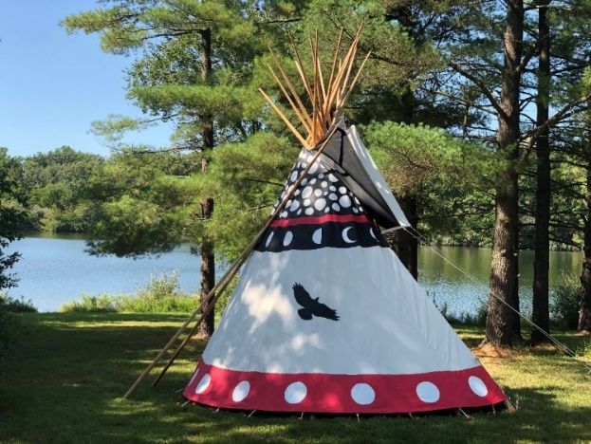
Please be prepared to carry your own gear to your campsite. A Gear Shuttle hauling gear to a designated pick up point close to all campsites will be available. Wagons and staff members may be available to help you, but plan as if it is not.

Webelos Adventure Camp

Basic Information
A 2-Night/3-Day adventure at Saukenauk Scout Reservation located 25 miles north of Quincy and 4 miles east of Lima, Illinois. Scouts have the opportunity to experience life-changing adventures as they learn new skills, make new friends, and experience nature like never before! This camp is intended for Youth entering 4th and 5th grades in the fall, parents, leaders, and Den Chiefs

Preparation for Scouts BSA
Based upon great feedback from leaders, parents, participants, and Scouts, we are doubling down on preparing your Webelos to attend Scouts BSA Camp.
- Registration will be done as a unit via our Summer Camp Registration System
- We encourage you to work with Scouts to select their Adventure/Activities, just a Scoutmaster would their Merit Badges
- Activities will be spread out over multiple days, just like at Troop Summer Camp. That means if you take Aquanaut, you’ll get wet every single day in our lake.
- Read on through this guide for more great updates and new things!

Saukenauk Scout Reservation
Adventure awaits at this back-woods property with 600+ hundred of acres to roam and explore. This camp focuses on adventure and shooting sports while still maintaining the traditional camp experiences.

- Session A June 29- July 2, 2022
- Session B August 4-7, 2022

Webelos Adventure Camp
2022 Early Bird  If paid by 4/15/22 | $160/Scout  $85/Adult
2022 Standard Price  If fees paid after 4/15/22 | $185/Scout  $110/Adult

Adventure Sign-up
You may begin signing up for adventures on April 15, 2022. The Summer Camp Registration Portal can be accessed through www.mississippivalleybsa.org and click on the camping section. Due to limited space and resources, some adventures may have a cap and will be filled on a first come, first serve basis.

Units that do not sign-up online will need to see what programs are available at camp after the Leader’s Meeting, and there is no guarantee that all activities will be available at that time.

Adventure Pins
Aquanaut: Swimming is a great exercise and a whole lot of fun. In this adventure, Scouts will discover how to enjoy swimming and how to respond to water emergencies. This adventure can be completed at camp.

Cast Iron Chef: Scouts learn how to prepare food in the outdoors using different types of cooking methods. Scouts will be preparing and cooking their own lunch during this adventure.

Castaway: To survive in the wilderness, you need to learn survival skills. This adventure will help Scouts learn some necessary skills needed to survive in an emergency.

Outdoorsman: There’s nothing better than living in the great outdoors. This adventure will get you ready for a lifetime of outdoor fun. Requirement 1 should be completed prior to coming to camp

Movie Making: Let’s make our own movie! Scouts will learn the process of making short films. Each session will focus on portions of the scout law and oath to make a movie. Movies will be combined to make one single movie on the scout oath and law which will be available for viewing during Parents night. This adventure will be completed at camp.

Walkabout: Hiking is what this adventure is all about. Scouts will learn safe hiking skills prior to taking a 3 mile hike. Scouts will prepare food for the hike and have a snack during the hike. Requirement 2 won’t be completed.

Aware and Care: Everyone has challenges–and understanding the challenges of others leads to acceptance. In this adventure, Scouts will learn firsthand how people live with disabilities that affect their sight, hearing, dexterity, & mobility; with this new understanding, they can help educate their peers and prevent hurtful exclusion of others.

Non-Advancement Adventures
Boating: Hop in a canoe and paddle the lake. Staff will be available to help scouts learn how to properly paddle a canoe and learn important safety guidelines. BSA requires at least one blue swimmer in each canoe.

Shooting: Learn proper handling and shooting techniques while using firearms. Experience the use of a bow and arrows while walking the Active Archery Range trail.

Rappelling: Rappel down the climbing wall at Saukenauk. Space is limited so sign up early. Rappelling is separated into two levels. Level II is for all those scouts who have had experience in rappelling and wants to challenge the outer wall. Level I are for those rappelling for their first time or for those scouts who prefer not to go over the outer wall.

Open Bouldering: Bouldering allows scouts to use the climbing wall and climb around the wall instead of up.

Service Project: Scouts can live out the Scout Law and Oath while performing service projects. Please keep track of the number of scouts and scouters who participate and record them as service hours for your packs.

Open Fishing: Bring your fishing gear and bait and head to the pond and try your luck at fishing. A limited supply of fishing poles are available and bait may be purchased in the trading post.

Sunday Check-in procedures:
You’re finally here! Plan on arriving at camp as a Unit, and park in the parking lot anytime after 11:00am. Please proceed Directly to your Campsite and begin setting up. Your campsites Site Guide will arrive sometime after 12:30 to welcome you to camp, check you in, and take you through the camp orientation. Please note that check in will be done at the campsite and not at the Trading Post.

Orientation
Meet Your Unit’s Site Guide – Site Guide will meet you at your campsite sometime between 12:30 and 1:30pm. Your Site Guide will stay with you throughout Sunday to assist in setting up your campsite and to walk you through the orientation.

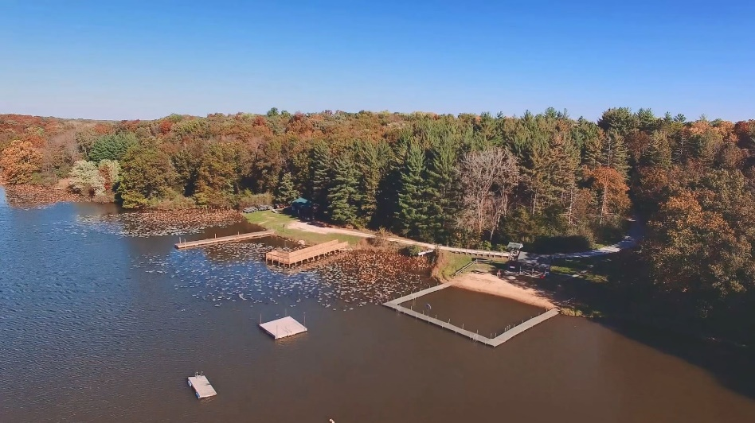
Unload gear and set-up camp – Units that bring trailers will be allowed to drive one vehicle back to their campsite to drop the trailer for the week. Additional vehicles will not be allowed to drive into camp. Please plan accordingly.
One adult leader will be directed to the check-in area to meet with the Camp Director. If you have worked everything out in advance, your registration should go smoothly. Please don’t wait until camp to pay fees or ask unanswered questions as this slows down check-in for other Packs behind you.

Medical Check – Please bring all official complete BSA medical forms and medications with you to this recheck. We can only accept fully completed, signed, and official BSA Health and Medical Records. If you have a Unit Lock Box for medications, you may keep prescriptions in your campsite. Also bring any Scout or Scouter that may need to talk to the Health Officer about particular medical conditions or medications. Please note the vaccination policy in our Health and Safety chapter at the end of this guide.

Swim Checks – All Unit members (youth and adults) will participate in swim checks. You may do swim checks prior to arriving at camp (form in appendix). You will still need to visit the swimming area for an orientation.

Den Orientation – Both our stellar camps follow the Patrol Method which is, as our Founder stated, not simply a way to run the Scouting program but the only way to run the program. Dens are guided by Akela (usually the Den Leader) but Scout Patrols are guided by an elected Patrol Leader.

Dining Hall Orientation – Learn the do’s and don’ts for our Dining operations this summer as well Dining Hall etiquette.

Camp Tour – Yes, we know that many of you have been to camp before. That begin said, many of our activity locations change from year to year depending on the facilities/equipment needed, timing of the activities, and other factors. Please attend the camp tour so you know where ALL activities and adventures are.

Dining Hall
We aim to maximize the amount of time your Scouts get to spend working on adventures, exploring, adventuring, and making memories.

Breakfast
Breakfast will be served continental style with hot and cold items. There will be no formal flag raising in the morning. We encourage you to hold your own at your campsite in the morning or to raise your flag at the SSR Court of Flags at your leisure. Breakfast will be served from 7:30 AM to 9:00 AM. There will be no assigned seating or table waiters. You may eat with whomever you would like. You do not need to attend as a Pack, we will leave that up to each individual unit. We are fine if Scouts want to sleep in or skip breakfast entirely, that is a unit decision.

Lunch
Sack lunches will be provided each day. This does not necessarily mean a cold lunch each day. Lunches will be distributed from the Dining Hall. You may eat wherever you like and with whom you’d like. Please clean up after yourselves.

Dinner
Dinner will be served per tradition with a buffet line, salad bar, and after-meal song.

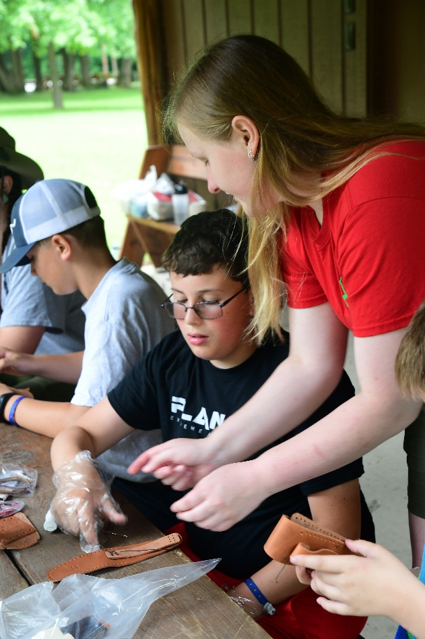

Daily Camp Schedule
 | Thursday | Friday | Saturday | Sunday
7:30 |  | Continental Breakfast
8:00
8:30
9:00 |  | Rotation 1
9:30
10:00 |  | Rotation 2
10:30
11:00 |  | Rotation 3
11:30
12:00 | Check In | To-Go Lunch
12:30 | Set up Campsites
13:00 |  | Leader Mtg |  | Camp Closed
13:30
14:00 |  | Rotation 4
14:30 | Camp Tour  Swim Checks  Dining Hall Orientation
15:00 |  | Rotation 5
15:30
16:00 |  | Rotation 6
16:30
17:00 |  | Pick Up Food
17:30 | Flags & Dinner | Cook At Campsite | Flags & Dinner
18:00
18:30 | Battleship |  | Beach Party
19:00 |  | Pelt Pouch Making
19:30 |  |  | Outdoor  Movie
20:00 | Campfire | Sunset Painting
20:30 |  | Pack Campfire /  Music Under the Stars
21:00
22:00 | Quiet Time | Quiet Time | Quiet Time

Activity Times
 | 9:00am 10:00 am 11:00 am 2:00 pm 3:00 pm 4:00 pm
AQUATICS
Aquanaut | x |  |  | X
Canoeing |  | x
Rowing |  |  | x
Instructional Swim |  |  |  |  | x
Open Swim |  |  |  |  |  | x
SCOUTCRAFT AREA
Cast Iron Chef |  |  | x |  | x
Castaway |  | x
Build a Better World | x
Leatherwork |  |  |  | X
Fire Building |  |  | x |  | x
Whittling Chip & Basic Carving |  |  |  |  |  | x
NATURE
Astronomy |  |  |  |  |  | x
Fishing | x
Webelos Walkabout |  |  |  |  | 2 Hr Activity
Into the Wild |  |  | x
Earth Rocks |  |  |  | X
Into the Woods |  | x
Adventures in Science |  |  |  |  | x
OLDER SCOUT PROGRAM
Archery | x |  |  | X
BB |  | x |  |  | x
Slingshot |  |  | x |  |  | x
Rappelling/Climbing  (July 1 & Aug 6 Only) |  |  |  | X | x | x
Build It |  | x
Bouldering | x | x | x

Activity | 9:00am | 10:00am | 11:00am | 2:00pm | 3:00pm | 4:00pm | Notes | Prerequisits | Requirements
Green Bar
Pioneering | x
Branding |  |  |  |  |  | x
Orienteering |  | x
Developing Your Patrol (Name/Flag/Yell) |  |  | x
Conservation Service Project |  |  |  | X |  | x
Cub Scout World Conservation Track
Build a Better World | x
Into the Woods |  | x
Into the Wild |  |  | x
Earth Rocks |  |  |  | X
Adventures in Science |  |  |  |  | x
Conservation Service Project |  |  |  |  |  | x

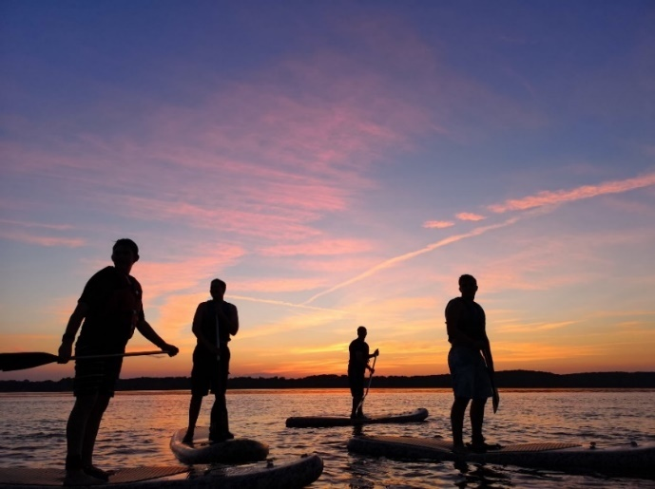

Organizing Your Unit

Unit Leaders
If you are a leader, make sure you are familiar with this guidebook, check the website often, and attend Roundtable for up-to-date information. https://www.mississippivalleybsa.org/camps/

Start by prepping your Unit early and promote camp year-round to help keep Scouts excited about summer camp.
- Attend a Pre-Camp Leaders meeting.
- Mark all deadline dates (deposits, Camperships, final payment dates, meetings, etc.) on the Unit’s calendar.
- Work with families and promote camp fees to help Scouts be “Thrifty” and earn their way to camp and help the Unit’s Committee with budgetary needs for camp.
- Schedule time with each Scout to go over possible Merit Badges and special programs
- Schedule time with the Order of the Arrow to conduct unit elections.
- Conduct a “Pack Camp Kick-Off” to inform families of plans and answer questions.
- Finalize Rosters and submit merit badge preferences online via the camp registration system
- Organize all Health Forms, payments, and travel for camp.

We encourage you to take the following steps:
- Schedule a time during your Pack Meeting for dens & Scouts to review the merit badge schedule.
- Have them write out which merit badges they desire to take and an alternate in case the class is full
- Make sure to talk with the Scout about prerequisites, things they must do before camp or they will not complete the badge and will receive a ‘partial’ to which they will need to find a counselor to complete

Tent & Cot Rental
Canvas Wall Tents and Cots are available for use free of charge. Please email mvc@scouting.org to reserve your gear.

Parents
Informed families can greatly enhance your Scout’s summer camp experience and ease anxieties for first time campers. Be familiar with this guidebook and work closely with your Unit leadership to stay informed.

- Mark all deadlines on your calendar – ask your Unit leader as they may require earlier deadlines in order to process all Unit members’ money and paperwork before they turn it in as a Pack.
- Schedule time to get your physical done. Use the official BSA Health and Medical Form and turn it into your Unit. We suggest you keep a copy for your records.
- Work with Unit Leadership to find out which Merit Badges and programs are good for the Scout.
- Look through suggested items to bring to camp and work with Unit leadership to determine all gear to be taken to camp.
- Attend “Unit Camp Kick-off” to get latest information and ask questions.
- Mark Family Night Dates for camp and plan on attending and supporting your Scout!

What to Bring to Camp
You'll want to be prepared for your week at camp. The following lists should be a good beginning. Feel free to add to the list, and check with your unit as to what equipment may be provided.

- Completed and signed BSA Health and Medical Form (Any other form will NOT be accepted).
- Medications labeled with easy to read directions for the Medical Officer
- Scouts BSA uniform: shorts, shirt, socks.
- Scouts BSA Handbook
- Flashlight
- Appropriate hat (Cub Scout or Scout hat preferred)
- Appropriate summer clothing: i.e. t-shirt & shorts
- Notebook and pencils
- Personal gear (towel, soap, toothbrush/paste, comb)
- Raincoat or poncho
- Sleeping bag or blankets
- Sneakers and/or hiking shoes
- Shower shoes or aqua-socks
- Spending money for the Trading Post OR a refillable Pre-Paid Card!
- Sweatshirt or light jacket
- Swimsuit
- Underwear and socks
- Bug spray (non-aerosol)
- Sun screen (non-aerosol)
- Merit Badge Books for merit badges for which you are registered.
- Small lock box for important items
- Pack & Den flags
Optional
- Camera and film
- Clothes hangers
- Clothes line or rope
- Compass
- Individual first aid kit
- Musical instrument
- Pocket knife
- Watch

Please do NOT bring:
- TV’s and gaming systems
- Expensive jewelry or clothing
- Fireworks
- Gasoline fueled stoves or lanterns
- Guns or weapons of any kind

Camp Rules
All units in camp must have at least two (2) leaders with the unit 24 hours a day. One leader must be at least 21 years of age. The second leader must be at least 18 years of age. Leaders may rotate if necessary.

The consumption, possession or use of alcohol in any form, and all controlled or illegal substances while on or near the premises of camp property is not permitted. Being under the influence or even having alcohol on the breath is a negative influence on our youth. Those individuals will be asked to leave, whether they are campers, leaders, staff, or visitors.

No firearms, bows, or arrows of any kind may be brought to camp. Absolutely no fireworks or personal ammunition of any kind are permitted at camp.

Liquid fuels are not permitted at camp. Propane may be used, but only under the supervision of an adult.

No fires or open flames are allowed in or near tents. This includes self-contained stoves and lanterns, mosquito coils, citronella candles and other such items. All tents must be clearly marked, “NO FLAMES IN TENTS.”

Sheath knives are not practical for the type of camping done at summer camp. Do not allow your Scouts to bring them to camp.

Avoid using aerosol spray cans while at camp wherever possible.

Leaders do not smoke in program areas, campsites or anywhere in the presence of youth. Smoking is not permitted inside any camp structures. A designated area will be available for those wishing to do so.

Campers and RV’s are not permitted in camp without prior approval of the Scout Office.

No electricity, except solar, is to be generated in campsites which includes running of extension cords from power sources.
Units that have disability needs will work with the Camp Director prior to camp to accommodate where possible.
Batteries (inverter and/or rechargeable marine batteries) used for medical needs are allowed to be recharged at a location specified by the Camp Ranger. Vehicles will not be allowed to be used as sources of power in campsites.

All private vehicles are to be parked in the camp parking lot. Unit trailers can remain in the campsite.

Personal bicycles are not permitted on camp property during summer camp.

No pets are to be brought to camp.

No additional family members or additional guests will be allowed to stay at camp unless they are registered campers.
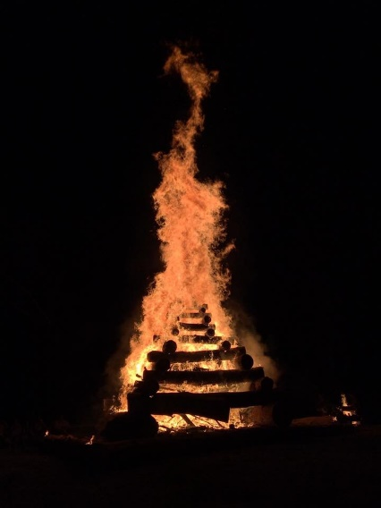
Identification Bracelet - Each Scout and adult leader will be issued a color-coded bracelet for identification purposes. These bracelets must be worn at all times.

Closed toed shoes/sandals must be worn-please no flip-flops or open-toed sandals. This is done for safety reasons. Flip flops/open-toed sandals are allowed in the shower house, pool, and beach area.

Youth Protection policies & adequate adult leadership are required at all time.

Adult Leadership
Youth Protection and Guide to Safe Scouting policies apply. Please remember two deep leadership is imperative. There must be one adult for every five Scouts attending with a minimum of two adults in camp at all times. Youth Protection Training may be taken as a self-study e-learning course at www.scouting.org.

Advancement
It is not the responsibility of the Camp Staff to sign off on any requirements. It is not the prime objective of Camp to whiz through the advancement. Instead, advancement is a byproduct of our program. The program will include opportunities for Webelos and Arrow of Light Scouts to work on their specific adventure pins and elective adventures. Some activities will require work before or after camp to complete adventures.

Den Chiefs
Webelos Dens are encouraged to bring a Den Chief to camp to assist. The Den Chief Registration fee is the same as the adult. A Den Chief is a position of responsibility in Scouts BSA. The Den Chief will assist in your pack and den program and provide a mentor for your Scouts.

Siblings & Unregistered Parents
Siblings and parents of Scouts are welcome as visitors on Family Night. All visitors must check in at the Camp Office or Trading Post to get a Camp ID. Siblings of Cub Scouting age may attend and participate in activities. They will be charged the youth rate. Older siblings and Den Chiefs may attend and pay the adult fee. Infants and Toddlers not eating in the Dining Hall will not have a fee and must be accompanied by an adult at all times. They should still be signed in at the office.

Swim Qualifications
All Scouts and leaders participating in aquatic adventures will be tested by the aquatics staff and placed into one of three ability groups. Scouts who do not satisfy the requirements may retake the test as frequently as they desire.

Non-Swimmer – Anyone who either opted out of the test or was unable to complete the full test.
Beginner – Jump feet first into water over your head, come to the surface, level off, swim 25 feet, turn sharply, and come back to the starting point.
Swimmer – Jump feet first into water over your head and surface. Swim 75 yards in a strong manner using one or more of the following strokes: sidestroke, breaststroke, trudge, or crawl. Swim 25 yards on your back, using the elementary backstroke. Rest by floating for 10 seconds.

Health and Safety

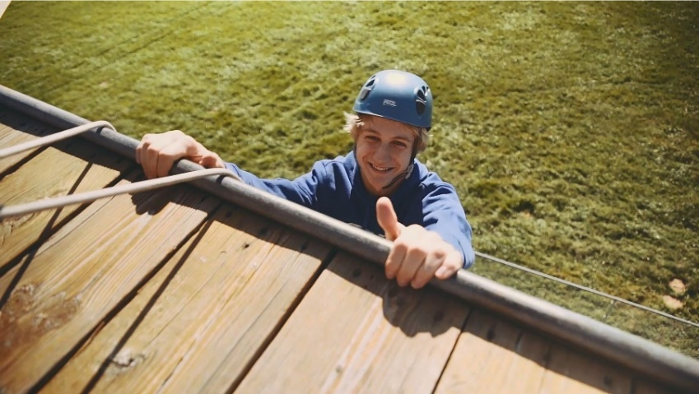
Health Lodge and Emergency Care
24-hour emergency medical care will be available by a competent Health Officer. A Scout or leader that has a medical problem should report to the Health Lodge as soon as possible. A medical doctor is on call for medical advice and emergencies and an AED is located in the Health Lodge.

Insurance
The Mississippi Valley Council provides accident and liability insurance for those persons registered in the Boy Scouts of America and are registered campers. No other youth are permitted to camp nor participate in the program of the camp for insurance reasons. Out of Council units must present proof of insurance from their council upon check-in on Sunday or mail to the Scout Service Center prior to the camp session. Any accident that occurs while they are at camp is covered first by your insurance and then our insurance kicks in second. Claim forms must be filled out by the parents and physician and submitted to the Scout Service Center. Additional information about filing claims can be obtained from the Council Service Center (217) 224-0204.

BSA Heath and Medical Records
Medical forms can be downloaded at the Council website at www.mississippivalleybsa.org, and are also included in this guide. A medical exam, with Physician’s signature and date, is required. A school, sports, or work physical exam is NOT acceptable. Any camper that does not have a physician’s signature on the BSA Health and Medical Record will not be permitted to stay on site for more than 72 hours. We suggest the family keeps a copy for their records.

Medication
While in camp, medications may be held by either the Health Officer or a Unit Leader. A Unit Leader may only keep medication if they can provide lockable storage at all times. All other medications will be checked in with the Health Officer on Sunday.

Vaccinations
Vaccinations will be required for 2022 per the Boy Scouts of America. See the most up-to-date listing of required vaccinations here: https://www.scouting.org/outdoor-programs/trail-to-adventure/immunization-policy-changes/

