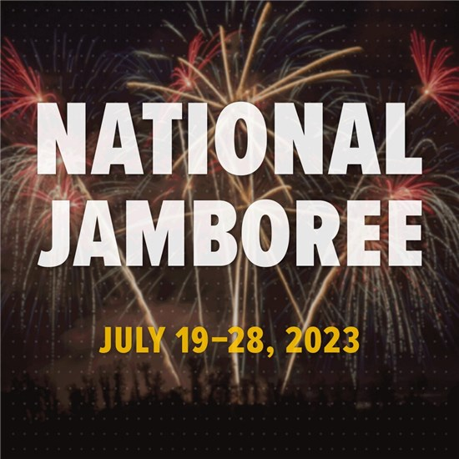

2023 National Scout Jamboree Youth Registration
July 19 – July 28, 2023

Name: __________________________________ Troop: ________

Home Address: ________________________________________________________________

City, State, Zip: ________________________________________________________________

Parent Cell Phone: _______________________ Youth Cell Phone: _______________________

Parent E-mail: _________________________________________________________________
Youth E-mail: __________________________________________________________________

BSA Membership Number ______________________________________________________

Signature of Applicant: ________________________________________________________

Signature of Unit Leader: ______________________________________________________

Payment Choice: *see reverse for details
_____ Full Payment ($2,800) ____ 3 Installments ($850 each)
All youth who register will receive a limited edition Jamboree Council Patch.
*Office Use Only*
Date: ___________ Payment Received: _______________ Receipt Number: ______________

