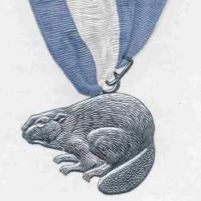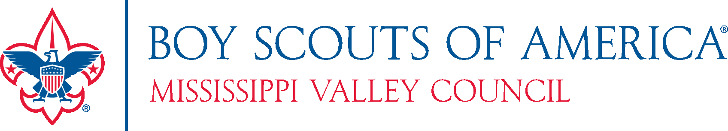

***You are Cordially Invited to   
The 2023 Annual Council Dinner***

*Saturday, February 25, 2023*

*PZAZZ! Convention & Event Center*

*3001 Winegard Dr., Burlington, IA 52601*

We will celebrate and recognize outstanding Scouters and the accomplishments that made our Council successful in 2022 and look forward to future progress in our Scouting World. This year’s theme is Casino Night!!

**EVENING HIGHLIGHTS**Silver Beaver Recognition – The highest award bestowed on a volunteer by the Scout Council

Pat Jackson Memorial Scholarship Presentation  
Top Popcorn Salespeople

**EVENING SCHEDULE**  
Social Hour – 5:30 PM – 6:30 PM

Buffet Dinner – 6:30 PM

**OVERNIGHT ACCOMMODATIONS**Room Reservations can be made by calling 319-753-2946 and ask for the **BOY SCOUTS Room Block**  
Room Rates: $179/night or $139.00/night and must be reserved before 2/10/23 – *Limited Availability!*

---------------------------------------------------------------------------------------------------------------------------------------

**COUNCIL ANNUAL DINNER REGISTRATION**

Make checks payable to: ***Boy Scouts of America***

***Register by February 1st and save $5.00 on your registration fee!***

____ Yes, I can attend! Reserve ____ seats at $40.00 per person ($35.00 if paid before 2/1/23).

____ Reserve a full table of 8 for $300.00 ($260.00 if paid before 2/1/23) – Please list names below

____ I cannot attend but have enclosed a donation to support the event.

Total Amount Enclosed: $_________________

Name(s) ______________________________________________________________________

E-Mail: _______________________________________________________________________

Sign up online <https://www.mississippivalleybsa.org/events/council-annual-dinner/>

Or mail to:

Mississippi Valley Council Mississippi Valley Council

2522 Locust Street ***OR*** 3007 Flint Hills Drive

Quincy, IL 62301 Burlington, IA 52601

If you have any questions, contact Katherine Noe at 660-223-0201