Scouting Makes a Difference!
Values found in the Scout Oath and Law, Motto, and Slogan teach Scouts character development, citizenship training, and personal fitness. These “Aims of Scouting” teach Scouts methods to live better lives and realize their full potential by instilling qualities such as self-motivation, focus, interest in the outdoors, technical skills, leadership abilities, and citizenship. The vision of the Boy Scouts of America is to prepare youth to become responsible, participating citizens and leaders, who are guided by the Scout Oath and Law.

A Nationwide survey showed that:
Of Senior Class Presidents 89% were Scouts.
Of Student Council Presidents 85% were Scouts.
Of School newspaper editors 88% were Scouts.
Of Football Captains 71% were Scouts.
Of Basketball captains 64% were Scouts.
72% of Rhodes Scholars were Scouts.
58% of West Point graduates were Scouts.
70% of Annapolis graduates were Scouts.
64% of Air Force Academy graduates were Scouts.
85% of FBI Agents were Scouts at one time.
36.4% of the United States Military Academy Cadets were involved in Scouting as youth. 16.3% of cadets are Eagle Scouts.
22.5% of United States Air Force Academy cadets were involved in Scouting as youth. 11.9% of cadets are Eagle Scouts.
25% of United States Naval Academy Midshipmen were in Scouting as youth. 11% of midshipmen are Eagle Scouts.
191 members of the 113th Congress participated in Scouting as youth and/or adult leaders. 28 are Eagle Scouts.
18 current U.S. governors participated in Scouting as a youth and/or adult volunteer. 4 are Eagle Scouts.
181 NASA astronauts were involved in Scouting (57.4 percent of astronauts). 39 are Eagle Scouts.

For every 100 youth that enter Scouts:
Only rarely will one appear before a juvenile court judge.
12 will belong to no church, but because of Scouting, 6 of these will find a home church.
3 will enter the clergy due to his Scouting relationships.
5 will receive church emblems.
45 will serve in the Military.
1 person will use Scout skills to save somebody else’s life.
2 will credit saving their own life to Scouting.
18 will later serve as adult volunteers in Scouting.
8 will find their future life vocations from Scouting.
18 will develop a lifelong interest or hobby due to Scouting.
- Scouts are 2x more likely to get a bachelor’s degree (75.6% of Scouting alumni compared to 36% national average)
- Scouts are 2x more likely to get an advanced graduate degree (29% of Scout alumni compared to 13.4% national average)
- Scouts are more likely to make double the income as adults ($62.5K median income compared with $33.7K national median)
- Scouts are more likely to have exceptional (750+) credit scores (55.7% of Scout alumni compared to 39.7% national average)

Famous Eagle Scouts Include:
Sam Walton -- founder of Walmart, Neil Armstrong -- astronaut, James Lovell -- astronaut, Hank Aaron -- baseball player, Gerald Ford -- president, John Glenn -- astronaut, Ross Perot -- politician, and Steven Spielberg -- director and founder of DreamWorks. The list of Eagle Scouts also includes Rex Tillerson -- CEO of Exxon Mobil, Hank Paulson -- Former U.S. Treasury Secretary and CEO of Goldman Sachs, J.W. Marriott Jr. -- Chairman and CEO of Marriott International, Walter Scott Jr. -- Former CEO of Peter Kiewit and Sons, John Edward Anderson -- CEO of Topa Equities Ltd., Stephen Bechtel, Jr. -- Co-Owner of the Bechtel Corporation, Charles F. Dolan -- Founder of HBO and Cablevision, Michael Bloomberg -- Mayor of New York City and founder of Bloomberg LP, L. Ron Hubbard -- Founder of the Church of Scientology, Michael Dukakis -- former governor of Massachusetts and presidential candidate, Robert M. Gates -- former director of the CIA, Michael Moore -- author and filmmaker, and Donald Rumsfeld -- former U.S. Secretary of Defense.

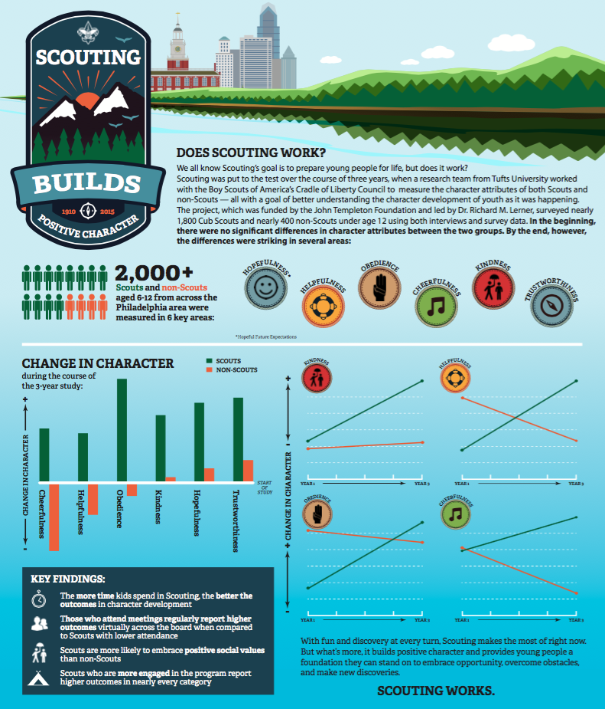
The BSA strives to bring larger, broader, and longer social impact. BSA Alumni continue to change the world by taking more leadership roles in organizations, engaging in more entrepreneurial activities, and undertaking more civic duties.
STUDIES LINK VOLUNTEERISM TO HIGHER EMPLOYEE PRODUCTIVITY & ENGAGEMENT
According to a report in the Athens Banner-Herald, a University of Georgia study found that employees who volunteer often show signs of increased productivity in the workplace, are more apt to help co-workers, worked harder, spoke positively about their workplace, wasted less time, missed less meetings, were higher performing, and have a greater sense of satisfaction.

