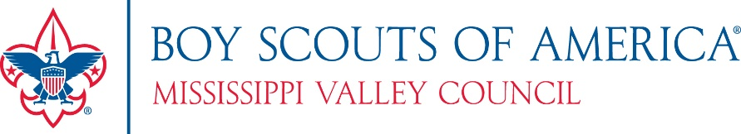

Effective August 1, 2023, the BSA will implement the following national membership fees which were approved by the National Executive Committee:

- $80 for Cub Scouts, Scouts BSA, Venturing and Sea Scouting participants ($5 increase)
- $60 for all adult volunteers ($15 increase to provide general liability insurance and enhanced background checks)
- $25 one-time joining fee for new program participants in Cub Scouts, Scouts BSA, Venturing and Sea Scouting (Not prorated and no change in fee)
- $25 for Merit Badge Counselors (New Fee applies only for Merit Badge Counselors not already registered as leaders)
- $100 for a unit charter/affiliation fee (no change in fee)
- $15 for Scout Life magazine

New Annual Membership Fee Process Announced – BSA Will No Longer Prorate Fees for New Members beginning August 1, 2023
Beginning August 1, 2023, all new youth and adult members who join Scouting will be enrolled in a 12-month membership cycle and BSA will cease prorating fees. Both youth and adults will pay the full annual membership fee and will renew their membership on the anniversary date of joining Scouting. All proration of membership fees will be eliminated. Each registered member of the BSA will receive an email notice with a registration renewal link beginning 60 days before the anniversary date they joined Scouting. Unit leaders will receive a copy of the email and should stay engaged in the membership renewal process just like rechartering.

It is important to note, existing members will renew their membership during their normal registration/recharter cycle through March 2024. Moving forward all members will renew on their anniversary date.
- Existing members’ Anniversary date will be their unit recharter month.
- New members’ Anniversary date will be the month they joined.

This new process will help streamline the rechartering and membership renewal process for units and councils. Additional information on this membership renewal process will be forthcoming in the very near future.

