Save the Date!
Plan to Attend
In-Person Program
Participate with friends & Fellow Commissioners, have Donuts and Coffee in the morning and Lunch included in the registration costs!
2024 Daniel Carter Beard
College of Commissioner Science
Hosted by: Councils of NST 4, 5 & 6
Hawkeye Area  Cedar Rapids, IA | Illowa  Davenport, IA | Mississippi Valley  Quincy, IL/Burlington, IA
Northeast Iowa  Dubuque, IA | Winnebago  Waterloo, IA | Mid Iowa  Des Moines, IA

Saturday, April 6, 2024  Marion Methodist Church  5050 REC Drive  Marion, Iowa 52302  Physical Doors Open at 8:00 am  Classes 9:00 am to 4:45pm  Read all information thoroughly before registering.  Course Catalog and Registration Information:  Degree Requirements, Daily Schedule, Course Descriptions, Overnight Lodging,  Directions to College, Information on Course Changes,  Personal Training History Record, and  Online Registration instructions.  Special Guest Speaker – David Berry  Topic – “Commissioners Role in S.A.F.E.” | 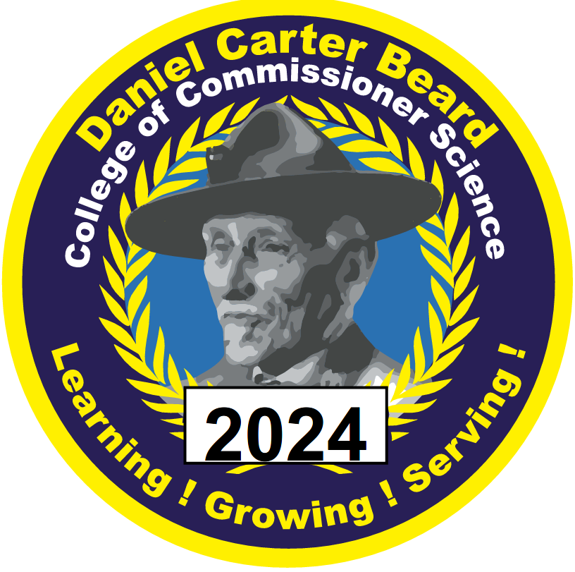
The Daniel Carter Beard College of Commissioner Science is a great opportunity,
for all commissioners and other Scouters to share experiences and learn new
Scouting information as well as earning Commissioner College Degrees.
Online registration and Course Catalog available in early 2024
College of Commissioner Science page on Hawkeye Area Council Web Site:

https://mycouncil.hawkeyebsa.org/Event/4805

